Valais Specialities

Raclette Cheese AOP (V) CHF 8.00 with new potatoes, silver onions & cornichons per plate

*Homemade Rösti – Potato with dry cured bacon IGP, CHF 26.00
raclette cheese, fried egg and side salad (V)

*Homemade Rösti – Potato with sliced apple, raclette cheese, CHF 24.00
apple sauce and side salad (V)

*Homemade Cholera served with a mixed salad (V) CHF 22.00
(Onions, potatoes, raclette cheese, sliced pears, sliced apples and leeks
in puff pastry – oven cooked)

Valais Plate CHF 26.00
Dry cured Beef IGP, Ham IGP, Bacon IGP & Sausage,
Raclette Cheese AOP, Rye Bread AOP. Served with cornichons and silver onions.

Cheese Fondue: All served with bread, cornichons & silver onions (V)
Classic (cooked with Fendant White Wine) CHF 27.00
Brömbar (House Special cooked with Guinness) CHF 30.00
Truffle (cooked with Truffle) CHF 35.00
Valais (cooked with tomatoes) served with potatoes CHF 30.00

Cheese fondue Menu: Salad, Fondue & Apricot or Pear Sorbet with schnapps. +CHF 10.00
Please choose one type of Cheese Fondue to create your menu.

* Käseschnitte Natural with a Fried Egg (V) CHF 22.00 (Oven cooked bread soaked in white wine and covered in Raclette cheese)
* Käseschnitte with Tomato and a Fried Egg (V) CHF 24.00
* Käseschnitte with Ham, Tomato and a Fried Egg CHF 26.00

*Please allow upto 25 minutes

(V) = Vegetarian

If you have any special dietary requirements, please do not hesitate to speak to a member of staff. We would be happy to help you in any way. All dishes are also available as children's portions.

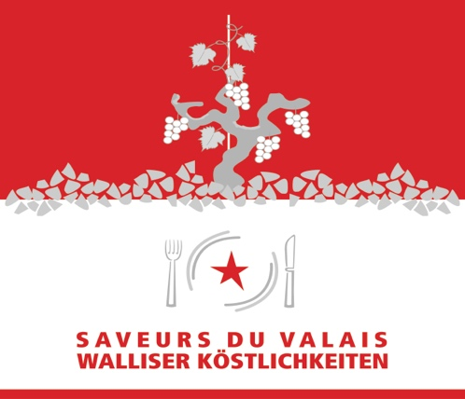
AOP - Appellation d’Origine Protégée
IGP - Indication Géographique Protégée
Preise inkl. 7.7% MWSt.

